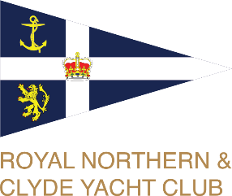
North Clyde Regatta 2024
Royal Northern and Clyde Yacht Club
21 & 22 September 2024
Upper Firth of Clyde, Scotland
SAILING INSTRUCTIONS

The Organising Authority is the Royal Northern and Clyde Yacht Club
The notation ‘[NP]’ in a rule of the sailing instructions (SIs) means that a boat may not protest another boat for breaking that rule. This changes RRS 60.1(a).
1 RULES
1.1 The event is governed by the rules as defined in The Racing Rules of Sailing (RRS) 2021 – 2024, the prescriptions of the RYA, IRC Rules Parts A, B, and C, the World Sailing Offshore Special Regulations (OSR), CYCA Handicap System and Class Rules for One Designs and local rules referred to in SI 18.2.
1.2 In case of conflict, the Sailing Instructions prevail over the Notice of Race. This changes RRS 63.7
1.3 The IRC rules available at www.ircrating.org will apply (except for Part D that will NOT apply).
1.4 The CYCA Handicap System available at www.cyca-online.org.uk will apply.
2 NOTICES TO COMPETITORS
2.1 Notices to competitors will be posted on the official notice board located at www.rncyc.com/north-clyde-regatta-2024. There will be no physical notice board.
2.2 The race office is virtual and can be contacted via 07596608035 or sailing@rncyc.com during the event or to the Club phone number or e-mail prior to the event (until 1200 on 20th September.) 01436 820332 or office1@rncyc.com.
2.3 On the water, the race committee intends to monitor and communicate with competitors on VHF radio channel 72. An alternate Channel 77 will be used if 72 is busy, indicated by displaying International Code W.
3 CHANGES TO SAILING INSTRUCTIONS
3.1 Any change to the sailing instructions will be posted before 0900 on the day it will take effect, except that any change to the schedule of races will be posted by 2000 on the day before it will take effect.
3.2 Changes to a sailing instruction will be indicated by the PCV by displaying Code flags A over L with two sound signals with the numeral pennant for the latest amendment.
3.3 Classes may be altered, amalgamated or divided at the discretion of the Race Committee. A decision of the classes for the first race on Saturday will be given with the list of entries and posted on by 2000 on Friday.
3.4 Courses for Each of the Classes. These will be broadcast not later than the warning signal and may be repeated before the one-minute signal.
3.5 Failure by the Race Committee to make a broadcast by VHF or to time it accurately will not be grounds for a request for redress. This changes RRS 62.1(a)
4 SIGNALS MADE ASHORE
4.1 Signals made ashore will be displayed at the flagpole at Rhu Marina near the Marina Office.
4.2 When flag AP is displayed ashore, ‘1 minute’ is replaced with ‘not less than 60 minutes’ in Race Signals AP.
5 SCHEDULE OF RACES
5.1 Number of Races: The Restricted Sail Class(es) and Two Handers will have one passage race each day, 21 and 22 September.
5.2 For other Classes the event will consist of up to 5 races with three races planned for Saturday and two on Sunday. Additional races may be sailed on either day, should the Race Committee deem this advisable at their sole discretion and this will be advised by VHF.
5.3 The warning signal for the first race will not be before 10.55 on Saturday and 10.25 on Sunday. Second and subsequent race sequences will be signalled as soon as possible following the previous race.
5.4 On Sunday 22 September, no warning signal will be made after 14.45.
6 CLASS FLAGS
6.1 The Organisers will publish class divisions and class flags on the official notice board and on the event website no later than Noon 20^{h} September.
6.2 Class flags may include:
IRC Handicap: Pennants 1, 3 and Flag R.
CYCA Handicap: Pennants 4 & 5.
White Sail: Pennant 9.
Sonar: Flag T, Etchells: Flag E, Sigma 33: Flag F, 707: Numeral 7.
6.3 Six or more competitors are required for a class start.
6.4 One Design boats need not display a class flag. Other classes shall display their class flags prominently on their backstays [DP].
7 RACING AREA
7.1 Races will take place off Helensburgh in the East Patch Race Area and in the Upper Firth of Clyde within approximately five miles of Rhu Marina. Chart 1994.
8 COURSES
8.1 For IRC, CYCA and OD Classes, courses will be set using the East Patch course chart around laid marks. Courses will be described over VHF. See Appendix A for mark locations.
8.2 For Restricted Sail and 2 Handed Classes, courses are described in Appendix B and the course number will be displayed on the Committee Vesel.
8.3 [NP] [DP] Boats shall stay clear of racing marks which are not part of their course, so as not to interfere with other classes.
9 MARKS
9.1 The description and approximate positions of fixed marks for IRC, CYCA and OD Classes are shown in Appendix A
9.2 The description and approximate positions of fixed marks for Restricted Sail and 2 Handed Classes are shown in Appendix B
10 OBSTRUCTIONS

10.1 Boats crossing the start/ finish line. Except on the first leg of a course boats shall cross the start/finish line at start of each round and at no other time unless finishing. At all other times the finish line is deemed an obstruction.
10.2 When not a mark of a course, Nav Bouy No 24 (12) must be left on the proper hand.

11 THE START
11.1 To alert boats that a race or sequence of races will be begin soon, an Orange flag will be displayed with one sound signal not less than five minutes before the first warning signal is made.
11.2 Races will be started using RRS 26 with the warning signal made 5 minutes before the starting signal.
11.3 The starting line is between an orange flag on the committee vessel at the starboard end and the course side of the port-end starting mark Z.
11.4 Sequence of starts will be announced on VHF and second and subsequent starting order may differ from that of the first starting sequence of the day, competitors must be alert to this being announced on VHF.
11.5 (DP) Boats whose warning signal has not been made shall avoid the starting area during the starting sequence for other classes.
11.6 If any part of a boat’s hull is on the course side of the starting line at her starting signal and she is identified, the race committee will attempt to hail or broadcast her sail number on VHF channel 72. Failure to hail or broadcast her number, failure of her to hear such a hail, or the order in which boats are hailed will not be grounds for redress. This changes RRS 62.1(a).
11.7 A boat that does not start within 4 minutes after her starting signal will be scored Did Not Start without a hearing. This changes RRS A5.1 and A5.2.
11.8 The Race Committee may combine two or more classes in one start, and ignore a class with no entries, without leaving gaps in the subsequent starting sequences.
11.9 After a General Recall, the class involved will be restarted at the end of the start sequence. A subsequent class which has been recalled will restart after the after the new start of the previous recalled class. This changes RRS 29.2.
11.10 Altering RRS Rule 30.4, sail numbers of boats subject to this rule will not be displayed but will be broadcast on VHF. It’s the responsibility of competitors to monitor VHF for starts when RRS 30.4 is in force.
11.11 If only one boat in any class appears at the start line, no race will take place for that class and no points awarded.
12 CHANGES OF THE NEXT LEG OF THE COURSE
12.1 The course may be changed during a race at the end of any “Round”. In this event and in alteration of RRS 33, IC flag C will be flown on the Committee Vessel and the description of the new Course will be repeated over VHF for IRC, CYCA and OD Classes. Repeated sound signals will be made to draw attention to the change of course.

13 THE FINISH
13.1 The finish lines will be as described by VHF or as described in the Appendices, if one of the courses in the appendices is to be used. This information will be given by VHF.

13.2 The finishing mark Z is to be left to Port of the Starboard committee vessel. Finish by crossing the line in the direction from the last mark.
13.3 If the race committee boat is absent when a boat finishes, she shall report her finishing time, and her position in relation to nearby boats, to the race committee at the first reasonable opportunity.
13.4 Restricted Sail and Two handed finished, as described in the course Appendix B
14 PENALTY SYSTEM
14.1 The penalty for a breach of a Rule other than a rule of RRS parts 1 and 2 may, at the discretion of the protest committee, be less than disqualification. This changes RRS 64.2
14.2 RRS 44.1 is changed so that the Two-Turns Penalty is replaced by the One-Turn Penalty.
15 TIME LIMITS
15.1 The Mark 1 Time Limit, Race Time Limit (see RRS 35), and the Finishing Window are shown in the table below.
Class | Mark 1 Time Limit | Race Time Limit | Finishing Window
Restricted Sail & 2 Handed | 60 min | 240 min | 75 min
All other classes | 40 min | 120 min | 30 min

15.2 If no boat has passed the first mark within the Mark 1 Time Limit, the race will be abandoned.
15.3 The Finishing Window is the time for boats to finish after the first boat sails the course and finishes. Boats failing to finish within the Finishing Window, and not subsequently retiring, penalised or given redress, will be scored Time Limit Expired (TLE) without a hearing. A boat scored TLE shall be scored points for the finishing place one more than the points scored by the last boat that finished within the Finishing Window. This changes RRS 35, A5.1, A5.2 and A10.
16 PROTESTS AND ARBITRATION REQUESTS
16.1 Protest and requests for redress must be submitted online via WhatsApp to 07596608035 to the race office within 60 minutes of the last boat finishing the final race of the or the Race Committee signals no more racing today, whichever is later. (Appropriate forms are available from Rhu Mariina Office or online at www.rncyc.com/north-clyde-regatta-2024. The time limit will be posted on the official notice board and WhatsApp.
16.2 Notices will be posted no later than 30 minutes after the protest time limit to inform competitors of hearings in which they are parties or named as witnesses. Protest hearings and Arbitration will be held in accommodation located at the Rhu Marina Marquee, beginning at the time posted.
16.3 The Post-Race Penalty and RYA Arbitration of the RYA Rules Disputes Procedures shall apply (for full information on the procedures, go to www.rya.org.uk/racing/rules/-disputes ). The outcome of an RYA Arbitration can be referred to a protest committee, but an arbitration cannot be reopened or appealed.
17 SCORING
17.2 For all classes one completed race will constitute a series. When fewer than five races have been completed, a boats score will be her total of her race scores. When five races have been completed, a boats score will be the total of her race scores excluding her worst score.
17.3 For Restricted Sail and 2 Handed Classes, a boat’s series score will be the total of her race scores.
17.4 Provisional and final results will be available as soon as possible after each race posted at www.rncyc.com/north-clyde-regatta-2023

18 SAFETY REGULATIONS
18.1 A boat retiring from a race shall notify the Race Committee by VHF as soon as possible. (DP)
18.2 [DP] NARROW CHANNELS. Attention is drawn to the International Regulations for the Prevention of Collision at Sea 1972. Particular notice shall be taken of Rule 9b which states “a vessel of less than 20 meters in length or a sailing vessel shall not impede the passage of a vessel which can safely navigate only within a “Narrow Channel or Fairway”. Whilst racing or on passage in the Firth of Clyde north of Cumbrae Head, yachts shall regard “Recommended Channels” marked as dotted lines on Hydrographic Office charts as a “Narrow Channel” within the meaning of the IRPCS 9b.
Furthermore, Clydeport Operations Limited has decreed that any waters of the Firth of Clyde where vessels by virtue of size, draught, speed or proximity to land, hazards and other vessels are unable to manoeuvre freely must be regarded as a “Narrow Channel”. Whilst racing, any yacht which is unable for reasons of lack of wind or other cause, to sail clear of a large power-driven vessel shall start her engine and/or paddle in order to clear and thereafter shall report full details to the Race Committee. (DP)
Competitors are reminded of the Clydeport Operations Limited Byelaw which prohibits yachts and other craft from manoeuvring within 100 meters of any ferry terminal. Particular regard shall be paid to this when in the vicinity of the Caledonian MacBrayne and Western Ferries facilities at Dunoon, McInroy’s Point, Hunter’s Quay, Largs, Cumbrae, and Wemyss Bay.
The Restricted Channels into the Gareloch, off Helensburgh Sailing Club and extending to the southern limit of the Kings Harbour may be closed for the passage of large military vessels.
Military vessels routinely transit the race area and can be accompanied by a security escort. Yachts and support boats should not shape a course to approach any military vessel or in any case pass closer than 200m to a warship or 400m to a surfaced submarine nor should high speed support shape a course, at speed, in the direction of a military vessel. The escorting security forces, if they consider any vessel is approaching a military vessel, will intercept and warn to keep clear.
The Regulations require all vessels to keep a listening watch on VHF Channel 16.
19 REPLACEMENTS OF CREW OR EQUIPMENT - Not applicable at this event.
20 EQUIPMENT AND MEASUREMENT CHECKS
20.1 A boat or equipment may be inspected at any time for compliance with the class rules, notice of race and sailing instructions.
21 EVENT ADVERTISING – Not applicable
22 OFFICIAL VESSELS – Not applicable
23 SUPPORT TEAMS – Not applicable
24 TRASH DISPOSAL –
24.1 (DP) Trash shall not be discarded overboard
25 HAUL-OUT RESTRICTIONS
25.1 [DP] Boats shall not be hauled out during the event except with and according to the terms of prior written permission of the race committee.
26 DIVING EQUIPMENT AND PLASTIC POOLS – Not applicable at this event
27 RADIO COMMUNICATION [DP]Except in an emergency, a boat that is racing shall not make nor receive voice or data communication that is not available to all boats.

28 PRIZES
28.1 Prizes will be given in each class for the first three places providing there are more than 5 competitors in the Class. A lower number of prizes may be given for smaller classes.
29 RISK STATEMENT
29.1 RRS 3 states: ‘The responsibility for a boat’s decision to participate in a race or to continue to race is hers alone.’
Sailing is by its nature an unpredictable sport and therefore inherently involves an element of risk. By taking part in the event, each competitor agrees and acknowledges that:
a) They are aware of the inherent element of risk involved in the sport and accept responsibility for the exposure of themselves, their crew and their boat to such inherent risk whilst taking part in the event;
b) They are responsible for the safety of themselves, their crew, their boat and their other property whether afloat or ashore;
c) They accept responsibility for any injury, damage or loss to the extent caused by their own actions or omissions;
d) Their boat is in good order, equipped to sail in the event and they are fit to participate;
e) The provision of a race management team, patrol boats and other officials and volunteers by the event organiser does not relieve them of their own responsibilities;
f) The provision of patrol boat cover is limited to such assistance, particularly in extreme weather conditions, as can be practically provided in the circumstances;
g) It is their responsibility to familiarise themselves with any risks specific to this venue or this event drawn to their attention in any rules and information produced for the venue or event and to attend any safety briefing held for the event.
30 INSURANCE
31.1 Each participating boat shall be insured with valid third-party liability insurance with a minimum cover of £3,000,000 per incident or the equivalent.

Appendix A – North Clyde Regatta 2024 – Sailing Instructions
1 IRC, CYCA and OD Classes – Course Chart
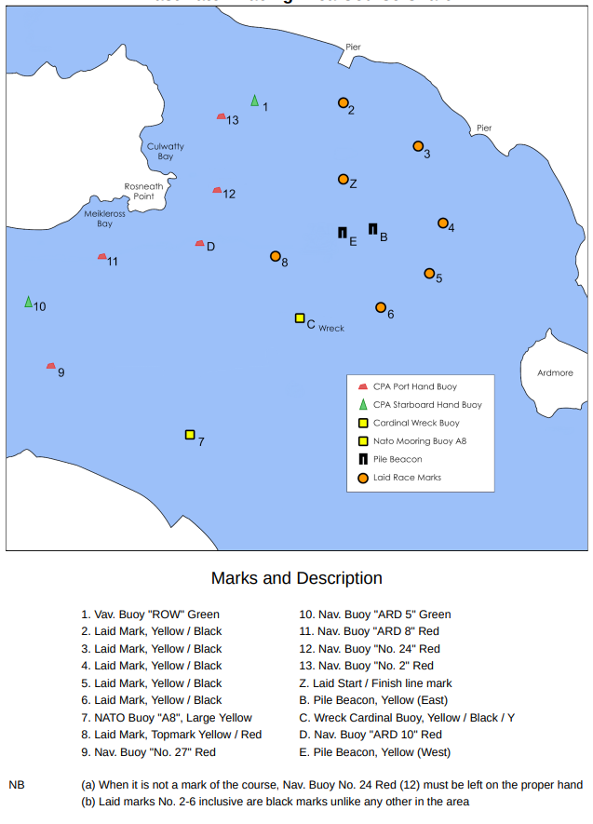

Appendix B – North Clyde Regatta 2023 – Sailing Instructions
Restricted Sail and 2 Handed CHART and COURSES
1 Coure Chart and Courses

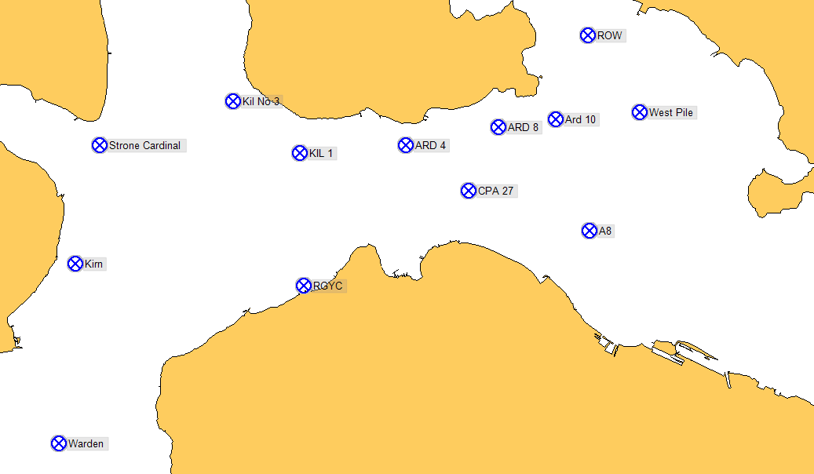
Short name | Latitude | Longitude | Notes
Start Marks |  |  | East Patch start line
Course Marks
Mark1 |  |  | Inflatable mark laid to weather of the start line
ARD 10 | 55° 59.016N | 004" 45‘.700W | Red Can CPA Buoy Ard 10
ARD 4 | 55" 58.757N | 004" 48’.372W | Red Can CPA Buoy Ard 4
ARD 8 | 55" 58.939N | 004" 46’.729W | Red Can CPA Buoy No 8
CPA 27 | 55" 58.306N | 004" 47'. 261W | Red Can CPA Buoy No 27
RGYC | 55" 57.350N | 004" 50'. 200W | Dayglo Orange, N of RGYC (RGYC ‘E’)
KIL 1 | 55" 58.631N | 004" 50’.268W | Green Conical CPA Buoy KIL 1
KIL 3 | 55" 59M98N | 004" 51 ’.454W | Green Conical CPA Buoy KIL3
Kirn | 55" 57’.570N | 004" 54’.264W | Yellow Special Mark
ROW | 55" 59’.856N | 004" 45M27W | Green Conical Buoy
Strone | 55" 53’. 761N | 004" 53’.826W | South Cardinal off Strone Point
Warden | 55" 55‘.777N | 004" 54’.555W | Warden Bank
W Pile | 55" 59'.037N | 004" 44’.202W | W Yellow Pile Beacon
A8 | 55" 57’.903N | 004" 45‘.096W | Yellow Mooring Buoy

2 FINISH FOR RESTRICTED SAIL
Boats in Restricted Sail and 2 Handed Classes should take their own times when rounding the Mark listed in RED/BOLD/UNDERLINE for potential shortened course, and when ARD 10 (Finish) bears due north magnetic and is no more than 20 meters distance and text these times to +44 7721 613081.

3 COURSES
The following generic courses are given. The course number will be displayed on the Committee Vesel.
(P) indicates marks to be rounded to port; (S) indicates marks to be rounded to starboard.

Course 1 Start – Marks 1 (P) – KIL 3 (P) – Warden Bank (S) – Strone (S) – RGYC (P) – KIL 1 (S) – CPA No 27 (P) – ARD 4 (S) – Finish
(about 20 miles)
Course 2 Start – Marks 1 (P) -ARD 10 – KIL 3 (P) – Warden Bank (S) – Strone (S) – RGYC (P) – KIL 1 (S) – CPA No 27 (P) – ARD 4 (S) – Finish
(about 21 miles)
Course 3 Start – Marks 1 (P) – KIL 3 (P) –Strone (P) – RGYC (P) – KIL 1 (S) – CPA No 27 (P) – ARD 4 (S) – Finish
(about 15 miles)
Course 4 Start – Marks 1 (P) –ARD 10 - KIL 3 (P) – Strone (P) – RGYC (P) – KIL 1 (S) –CPA No 27 (P) – ARD 4 – Finish
(about 15 miles)
Course 5 Start - Marks 1 (P) - KIL 1(P) - CPA NO 27 (P) - ARD 8 (S) - A8 (P) - W PILE BEACON (P) – ARD 8 (S) - Finish
(about 12miles)
Course 6 Start - Marks 1 (P) –ARD 10 - KIL 1 (P) - CPA NO 27 (P) - ARD 8 (S) - A8 (P) – W PILE BEACON(P) - Finish
(about 13 miles)
Course 7 Start - Marks 1 (P) – ARD 4 (P) - CPA NO 27 (P) - ARD 8 (S) - A8 (P) - W PILE BEACON (P) – ARD 8 (S) – Finish
(about 10 miles)
Course 8 Start - Marks 1 (P) - ARD 10 (P) – ARD 4 (P) - CPA NO 27 (P) - ARD 8 (S) - A8 (P) - W PILE BEACON (P) – ARD 8 (S) – Finish
(about 11 miles)

